The Old Gaol  The Old Goal was constructed in 1880 by James Gibbs and the Police Quarters in 1907. Both buildings are brick and iron and typical of government buildings of the period. Constable John Bovell was the first policeman to occupy the quarters.  The Old Gaol  148 Hampton St  Bridgetown |  | BHS Committee 2019  Chairperson: Mary Elgar  V-Chair: Phillip Anderson  Treasurer: Lorie Marshall  Secretary: Richard Allen  Cher Grace  Lee Wittenoom  Peter Hall  BHS Office Hours  Mondays 9 – 12 am  Thursdays 9 – 12 am  (Except public holidays)  O  Any other time by appointment  BRIDGETOWN HISTORICAL SOCIETY INC.  Old Yornup School House  5 Civic Lane  Bridgetown, WA 6255  (PO Box 1017)  08 9761 4236  bridgetownhistory@iinet.net.au  www.bridgetownhistoricalsociety.org.au |  |  | BRIDGETOWN HISTORICAL SOCIETY INC.  - New Members  - Information Leaflet  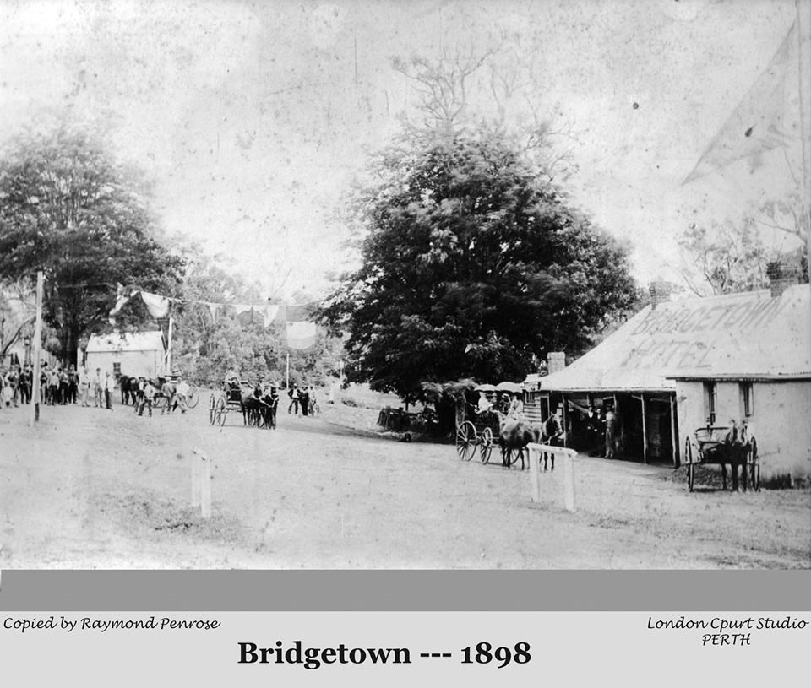
r
BHS OPEN NIGHTS  1st Tuesday, monthly, starting at 7pm.  Held in Old Yornup School House, Civic Lane, Bridgetown (via Shire car park opposite newsagency on Steere Street).  These nights are for members and non-members to hear what decisions were made and discussions held at the previous committee meeting. Frequently a speaker will be invited to attend to talk on a subject of historical interest.  MEMBERSHIP FEES  $12 renewal or $15 new member  Payable in September each year.  Discounts are offered to members for services e.g. photocopying, printing, scanning, research request or general assistance with research.  NEWSLETTER  A newsletter is produced quarterly (January, April, July and October). Members are encouraged to contribute articles and items of interest for the newsletter by email to bridgetownhistory@iinet.net.au  COMMITTEE MEETINGS  Held each month on first Monday at 4pm at the Old Yornup School House. |  | BHS COLLECTION POLICY  The main collection areas include: Bridgetown early settlement, agricultural development, railway history and photos relating to these topics.  Acceptance of Objects, Ephemera, Documents and Photos to BHS  (known collectively as Objects)  - Objects for donation must have originated, or been used within, the Bridgetown Greenbushes District  - Objects will not be accepted for acquisition unless they are in an acceptable condition to BHS  - If the Object being donated is a duplication of one already held by BHS, then BHS maintains the right to refuse acceptance of the Object, unless its value is significant and also if BHS has the wherewithal to house the object  - Gifts of Objects will only be accepted if accompanied by a BHS Donor Acknowledgement Form, signed by the donor and witnessed by a BHS member. This form is legally binding and the donor waives all rights and title to the Object once it has been donated  - Donors of Objects that have not been accepted by BHS are encouraged to contact WA Museums. |  |  | USE OF BHS OBJECTS  The use of any Object(s) that are the property of BHS requires written permission from the Committee before the Object(s) can be used for any purpose.  Please complete a BHS Object Request Form and send it to Admin bridgetownhistory@iinet.net.au  THE OLD GAOL  BHS manages a collection of donated Objects within The Old Gaol, as a museum of local interests. It is open on Saturdays between 10am and 2pm.  Old Gaol Roster  Each member is asked to volunteer at The Old Gaol bi-monthly, for one, two-hour session. The Old Gaol roster is drawn up monthly and members are asked to nominate which session they can cover. New members are mentored for the first few sessions so that they are comfortable with opening/closing The Old Gaol.  Additional volunteers will be required for large groups that book to go through The Old Gaol, or for special events.

